Table of Contents

Document Version 2

1. Purpose 3

1.1. Intended Audience 3

1.2. Intended Use 3

1.3. Scope 3

1.4. Definitions and Acronyms 3

2. Overall System Description 4

2.1. Use Case Diagrams 4

2.2. System Architecture 5

2.3. Functional Requirements 6

2.3.1. Sensor Deployment and Monitoring 6

2.3.2. Automated Fire Alert 6

2.3.3. Manuel Emergency Alert 6

2.3.4. Fire Suppression using Sprinklers 6

2.3.5. Multi-Modal Alert System 7

2.3.6. Mobile App & Remote Monitoring 7

2.3.7. AI-Powered Fire Risk Prediction 7

2.4. Non-Functional Requirements 8

2.4.1. System Qualities & Constraints 8

3. Software Architecture 9

3.1. Static Software Architecture 9

# Document Version

|  |  |  |  |  |
| --- | --- | --- | --- | --- |
| No | Update | Name | Date | Version |
| 1. | Initial version | Meena | 11/6/2025 | 1.0 |
| 2. | Changes to system diagrams and purpose | Phoo Pyae | 12/7/2025 | 2.0 |
| 3. | Changes to system diagrams and requirements | Meena | 13/7/2025 | 2.1 |

# Purpose

## Intended Audience

This SRS document describes the System Requirements and Software Design for an IoT-based Smart Fire Alert System, and the target audience are **System Designers, Embedded Engineers, SCDF Tech Division, and Emergency System Developers** working on the development of this project.

## Intended Use

The SRS defines the overall System Architecture and Requirements as well as the Software Architecture and Design. This document also contains the definition of the System Requirements which shall be used as the input for System Test cases and Software Unit Test cases.

## Scope

The Smart Fire Alert System is designed for deployment in rental apartments of elderly residents in Singapore. It aims to provide early detection and notification of fire events using multiple sensor modalities, automated sprinkler activation, and multi-channel alert systems

## Definitions and Acronyms

|  |  |
| --- | --- |
| **Acronym** | **Description** |
| IR | Infra Red |
| LED | Light Emitting Diode |
| NFC | Near Field Communication |
| SW | Software |
| HW | Hardware |
| SCDF | Singapore Civil Defence Force |
| IoT | Internet of Things |
| LCD | Liquid Crystal Display |

# Overall System Description

## Use Case Diagrams

## System Architecture

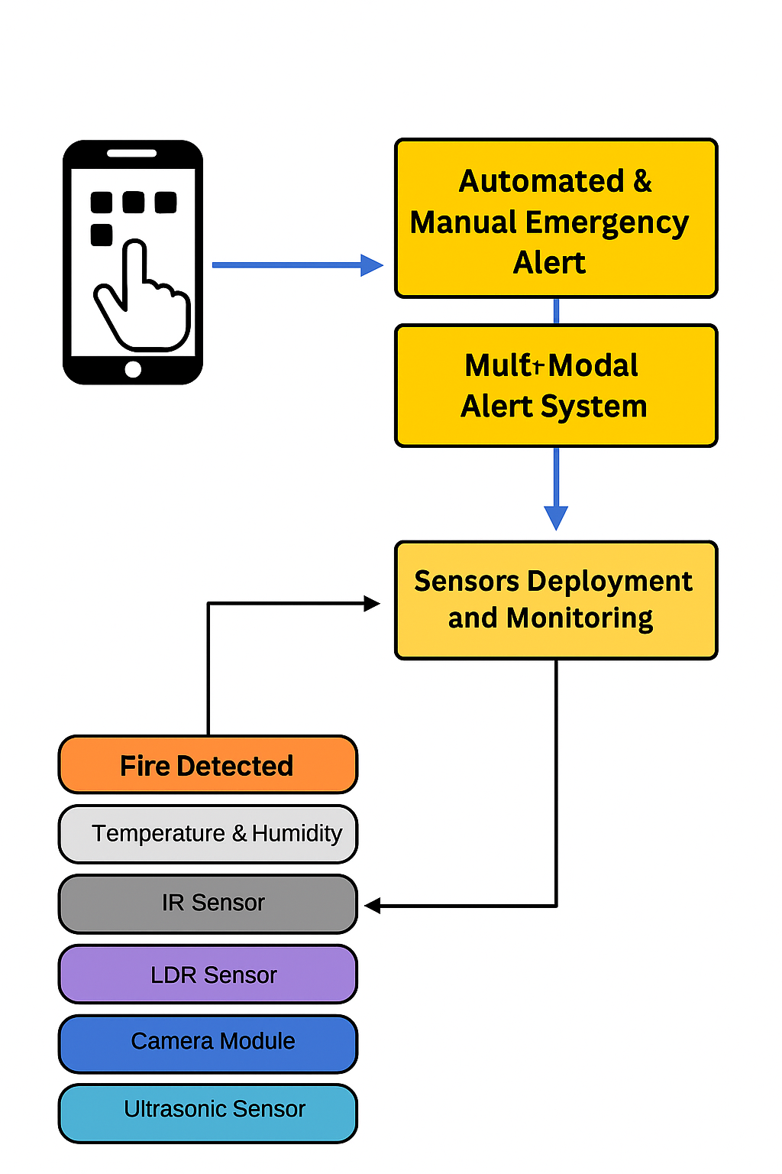

## Functional Requirements

### Sensor Deployment and Monitoring

The system continuously monitors the condition of the room using multiple types of sensors to detect early signs of a fire. Each sensor serves a specific role in identifying environmental changes that may indicate danger.

|  |  |
| --- | --- |
| **REQ_ID** | **Requirement** |
| REQ-01 | The system shall monitor the abnormal increases in heat or decrease in humidity for early indicators of fire, using temperature and humidity sensor. The fire detection threshold will start from a temperature of above 40°C |
| REQ-02 | The system shall detect black and white contrast caused by smoke in the room using IR sensor. The IR filters are chosen to isolate specific wavelengths, often in the 4.4-4.8 micrometre range, which are characteristic of hydrocarbon flames. By analysing the intensity and flickering patterns of this infrared radiation, the sensor can distinguish between a real fire and other potential heat sources, reducing the likelihood of false alarms. |
| REQ-03 | The system shall use LDR as secondary smoke detector to sense changes in light cause by smoke particles. |
| REQ-04 | The system shall analyse visual input by camera module to detect flame-like colour patterns which are orange-yellow spikes. |
| REQ-05 | The system shall use the Ultrasonic sensor to detect the human presence in the room and notify SCDF and other parties that people are physically present within a room's enclosed space where the fire is happening and urgent help is needed. |
| RED-06 | The system shall use the moisture sensor to detect and verify that the sprinkler system has been activated and is functioning as it should, without any issues or errors. If the moisture sensor is not activated in the case of a fire, it will notify SCDF and other respective parties. |

### Automated Fire Alert

When fire is detected by any of the above sensors or manually alerted, the system will trigger an alert to residents & sends a notification to SCDF.

.

|  |  |
| --- | --- |
| **REQ_ID** | **Requirement** |
| REQ-07 | The system shall automatically trigger a fire alert when any trigger from any of the sensors detected and visual detection |
| REQ-08 | The system shall use the data from camera module as a secondary sensor that works in conjunction with other sensors (IR, LDR, temperature and humidity sensor) to confirm the presence of fire before triggering an alert. |
| REQ-09 | The system shall escalate alert levels based on sensor combination and presence of occupants in the room from ultrasonic sensor. |
| REQ-10 | Upon detecting a fire, the system shall notify the Singapore Civil Defence Force (SCDF) and other residents through mobile app, including alert level. |

### Manuel Emergency Alert

In case of emergencies, residents should be able to manually alert SCDF or urgent help, if required.

|  |  |
| --- | --- |
| **REQ_ID** | **Requirement** |
| REQ-11 | The system shall allow users to manually trigger the emergency fire alert using a two-step activation process:   1. Slide switch must be toggled to the right side to activate 2. A correct keyword must be entered through the keypad |
| REQ-12 | The system shall allow users to manually deactivate the emergency alert through an RFID reader, which allow authorised personnel to deactivate the fire alarm by scanning a valid RFID tag. |

### Fire Suppression using Sprinklers

The system activates the sprinkler system in the affected room as the first line of defence upon confirmed fire detection from combination of sensors.

|  |  |
| --- | --- |
| **REQ_ID** | **Requirement** |
| REQ-13 | When fire is detected, the system shall activate the servo motor to open the sprinkler valve and release the water. |
| RED-14 | The system shall activate the DC motor to open the window to let all the smoke out as soon as fie is detected. |
| REQ-15 | The system shall escalate the alert level if the moisture sensor does not detect water release during sprinkler activation, indicating a possible failure in the suppression system. |
| REQ-16 | The system shall deactivate the sprinkler by stopping the DC motor when a manual reset and shutdown command is performed by an authorized user. |

### Multi-Modal Alert System

When fire is detected after confirmation from sensors, the system shall activate multiple types of alerts simultaneously to ensure all the residents, including those with disabilities are also effectively informed.

|  |  |
| --- | --- |
| **REQ_ID** | **Requirement** |
| REQ-17 | The system shall activate the LED to signal the presence of fire by signalling, regardless of the alert level. |
| REQ-18 | The system shall provide visual alerts from LCD screen showing real-time status of fire alert levels. |
| REQ-19 | The system shall activate the loud buzzer alarms to alert residents of the emergency. |
| REQ-20 | The system shall send push notifications via the mobile app indicating fire alerts and their corresponding alert levels. |

### 

### Mobile App & Remote Monitoring

The system provides a mobile interface for residents, and authorised users (e.g. caregivers) to monitor sensor data, receive alerts, and remotely manage emergency responses in real time.

|  |  |
| --- | --- |
| **REQ_ID** | **Requirement** |
| REQ-21 | The system shall be integrated with a mobile application that displays real-time sensor data and alert history. |
| REQ-22 | The app shall allow users to remotely acknowledge alerts and alert levels. |
| REQ-23 | Authorised users and SCDF shall receive alerts and updates remotely via the mobile application. |
| REQ-24 | In the event of a fire, the mobile app will be on complete lockdown, disabling your phone and all other app features, with a red display screen saying, “fire evacuate immediately”. To help visually impaired or deaf people, the phone will send multiple long vibrations to indicate the presence of a fire. When the fire has subsided or in the event of a false alarm the mobile app will enable your phone from using other app features. |

## Non-Functional Requirements

### System Qualities & Constraints

These requirements should define the performance of the system, the usability, maintainability and other operational expectations.

|  |  |
| --- | --- |
| **REQ_ID** | **Requirement** |
| REQ-25 | The system shall detect fire events with minimal false positives and false negatives. |
| REQ-26 | The mobile app shall present fire information and alert levels in a user-friendly and easy-to-use interface designed including large text and a simple layout to accommodate elderly users. |
| REQ-27 | The system shall be designed with configurable software and modular hardware components to allow deployment across multiple households without extensive reconfiguration. |
| REQ-28 | The system shall operate in real-time, responding to fire detection events within 10 seconds. |
| REQ-29 | The system interface (including manual switch / button), shall be easily usable by elderly residents with minimal training on the usage. |
| REQ-30 | The system shall be operational 24/7, with a minimum system uptime of 99.5%. |

# Software Architecture

## Static Software Architecture

The Software Architecture defines the various Software Components that are developed to realize the implementation of the system requirements.

**Application Layer**

**Hardware Abstraction Layer**

